Project

School Project

Theme:

Project: “PasswordGuesser”

|  |  |
| --- | --- |
| Made by:  Alexander Hristov  Georgi Georgiev  Dani Dimov  Zhelyazko Ivanov |  |
| Table of Contents  1. Authors 3  2. Summary 3  2.1. Goals 3  3. Difficulties 3  3.1. Logical and functional description of the project 3  3.2. Functions 4  3.2.1. Class Data 4  3.2.2. Class Presentation 4  Figure 1 4 |  |

Table 1 3

Table 2 4

Table 3 5

**Theme**

1. **Authors**

|  |  |
| --- | --- |
| Name | E-mail |
| Alexander Igorov Hristov |  |
| Georgi Kaloyanov Georgiev |  |
| Dani Stanimirov Dimov |  |
| Zhelyazko Alexandrov Ivanov |  |

Table 1

1. **Summary**
   1. **Goals**

Our main goal was to recreate the Terminal mini game from Fallout 3.

1. **Difficulties**
   1. **Logical and functional description of the project**

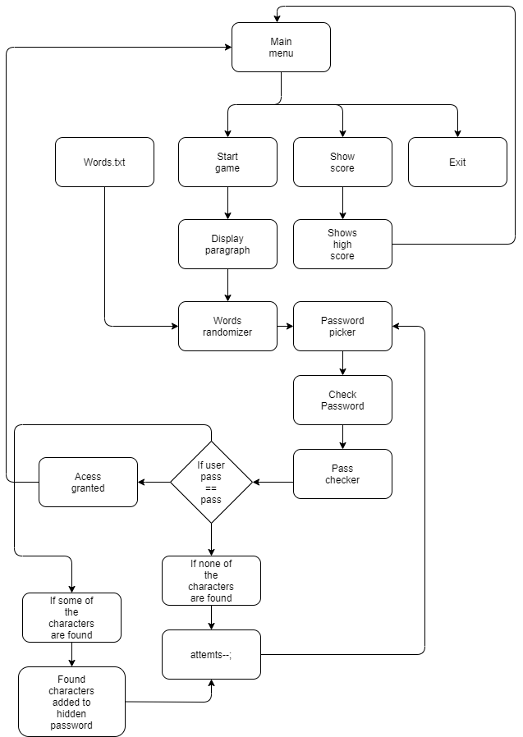This is the block scheme of our project:

Figure

* 1. **Functions**
     1. **Class Data**

|  |  |  |
| --- | --- | --- |
| Name of the function | Arguments | Description |
| takeFromFile | allWords, cnt | Takes all the words from words.txt so that the selectWords function can use random ones from it. |
| selectWords | allWords, finalFour, cnt | Selects random words from our list for the game. |
| selectPassword | finalFour | Selects the password from the chosen random words. |
| runGame | finalFour, allWords, cnt | Combines all functions and runs the game. |

Table 2

* + 1. **Class Presentation**

|  |  |  |
| --- | --- | --- |
| Name of the function | Arguments | Description |
| mainMenu | finalFour, allWords, cnt | Displays the main menu of our program. |
| DisplayParagraph | words[] | Displays the paragraph where the randomly generated words are placed. |

Table 3